# **Canada’s model building codes: A deep dive**

Model codes are building codes developed independent of any jurisdiction. They are only considered to be law when a province, territory, or local government adopts the model code as its own local building code.

Model codes are intended to relieve local authorities of the technical challenges and expense of developing their own building codes. They also offer a level of consistency between jurisdictions while allowing local authorities the opportunity to amend or adapt the model codes to suit their local conditions.

In Canada, the national model codes include:

* The National Building Code of Canada (NBC)
* The National Fire Code of Canada (NFC)
* The National Plumbing Code of Canada (NPC)
* The National Energy Code of Canada for Buildings (NECB)

This toolkit focusses on both the NBC and the NECB.

* The NBC is meant to regulate the design and construction, or substantial renovation, of new houses and small buildings.
* The NECB provides the minimum energy efficiency requirements for the design and construction of all new buildings and additions, except for farm buildings, it is typically used for large buildings.

## The national model code development system

Canada’s national model codes are developed by the federal government through the [Canadian Commission of Building and Fire Codes (CCBFC)](https://nrc.canada.ca/en/certifications-evaluations-standards/codes-canada/codes-development-process/canadian-commission-building-fire-codes). The CCBFC was established by the [National Research Council’s (NRC)](https://nrc.canada.ca/en/certifications-evaluations-standards/codes-canada/codes-development-process/canadian-commission-building-fire-codes) Institute for Research in Construction (NRC-CNRC).

The CCBFC oversees the development of [Codes Canada](https://nrc.canada.ca/en/certifications-evaluations-standards/codes-canada/codes-development-process/canadian-commission-building-fire-codes) publications and ensures standardized building regulations throughout Canada. The CCBFC is a volunteer-based decision-making body made up of over 400 members. Members participate in standing committees, task groups and working groups.

The provinces and territories participate in the model codes system by offering policy advice and direction through their own committee that communicates directly to the CCBFC. The [Provincial/Territorial Policy Advisory Committee on Codes (PTPACC)](https://nrc.canada.ca/en/certifications-evaluations-standards/codes-canada/provincialterritorial-policy-advisory-committee-codes) is a committee made up of senior representatives appointed by provincial and territorial deputy ministers. The PTPACC determines the priorities of the model codes and represents the authorities that adopt and administer the codes, the provinces and territories.

Several different organizations provide technical support related to building code development. These include the Canadian Codes Centre (CCC), [Natural Resources Canada](https://www.nrcan.gc.ca/home) (NRCan) and stakeholders from government, industry, and the public.

The Standing Committee on Energy Efficiency (SC-EE) plays a central role in the development of building energy codes. The SC-EE is made up of experts from industry and provides recommendations related to energy efficiency to the CCBFC on technical content.

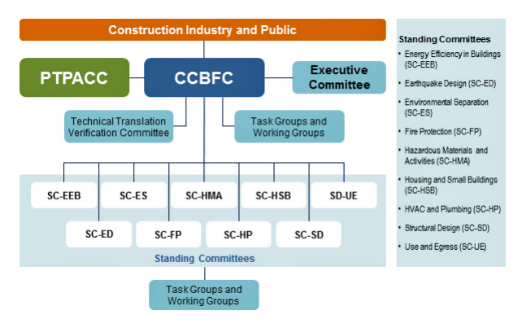

*Figure 1: NRC-CNRC, Canada's National Model Construction Codes Development System. Accessed June 2020.*

## How you can participate in the model codes process

Participating in the building codes review process is somewhat different than commenting in other policy areas. For example, codes comments must specifically address previously identified issues and the number of comments with shared perspectives is not a consideration. The CCBFC has [guidelines](https://nrc.canada.ca/en/certifications-evaluations-standards/codes-canada/codes-development-process/guidelines-comments) that specify how comments are to be submitted.

These include:

* Only comments directly related to a proposed change and that address an issue identified in the Proposed Change form’s “Problem” field will be considered by the committees.
* If a comment is not supportive of a proposed change, you must explain why that change is not supported.
* To be considered, comments should be backed with a technical reasoning for a requested change.
* Comments that raise issues the committees may have overlooked, bring to light economic implications, or in support of proposed changes are encouraged.

Comments cannot be submitted in any medium other than through the CCBFC’s [comment form](https://www.nrc-cnrc.gc.ca/eng/solutions/advisory/codes_centre/public_review/publicreview_comment.html) and all comments must be submitted individually for each proposed change. Comments provided are then passed to the relevant committees of the CCBFC and those committees will review all comments received. The committees will then decide to:

* withdraw the proposed change;
* recommend that it be reviewed further for possible re-submission in revised form in a future public review; or
* recommend that it be approved by the CCBFC, with or without modification.

If approved by the CCBFC, the technical changes will be published in future editions of [Codes Canada](https://nrc.canada.ca/en/certifications-evaluations-standards/codes-canada/codes-canada-publications/national-building-code-canada-2015) publications.